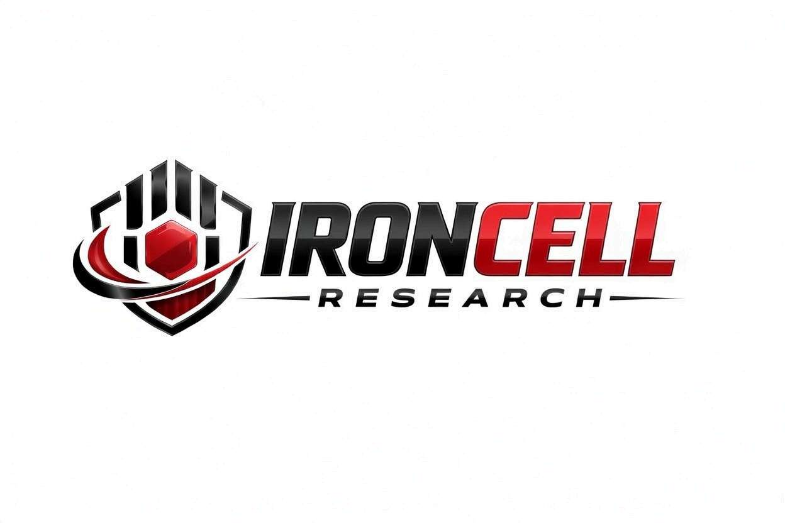
PEPTIDE RESEARCH BRIEF
Glutathione
L-Glutathione (GSH) | Master Antioxidant & Detoxification Tripeptide

Description, Benefits, Dosage & Research Overview

Iron Cell Research
IronCellResearch.com
For Research Use Only


Compound Overview
Compound Name | L-Glutathione (GSH / Reduced Glutathione)
Classification | Endogenous Tripeptide Antioxidant
Amino Acid Composition | L-Glutamate, L-Cysteine, Glycine
Molecular Formula | C10H17N3O6S
Molecular Weight | 307.32 g/mol
CAS Number | 70-18-8
Biological Half-Life | Approximately 1.5-4 hours (IV/SubQ)
Purity | Greater than or equal to 99%
Storage | Lyophilized, -20C, protected from light, heat, and moisture
Research Status | Extensive clinical and preclinical research across multiple indications

Description
Glutathione (GSH) is the most abundant intracellular antioxidant in the human body, present in virtually every cell at millimolar concentrations (1-10 mM). This tripeptide, composed of glutamate, cysteine, and glycine linked by a unique gamma-peptide bond between glutamate and cysteine, serves as the master regulator of the cellular redox environment.
Glutathione exists in two forms: reduced (GSH) and oxidized (GSSG). The ratio of GSH to GSSG is a critical indicator of cellular health, with healthy cells maintaining a ratio of approximately 100:1. This ratio declines significantly with age, chronic disease, toxin exposure, and oxidative stress, contributing to cellular dysfunction and accelerated aging.
Beyond its direct antioxidant activity, glutathione plays essential roles in Phase II detoxification, immune function, protein synthesis, DNA repair, amino acid transport, and the regeneration of other antioxidants including vitamins C and E. It is indispensable for mitochondrial function and protection against apoptosis.

Mechanism of Action

Direct Antioxidant Activity
Glutathione directly neutralizes reactive oxygen species (ROS), reactive nitrogen species (RNS), and free radicals through its sulfhydryl (-SH) group on the cysteine residue. In this reaction, two GSH molecules are oxidized to form GSSG, which is then recycled back to GSH by glutathione reductase using NADPH as the electron donor. This continuous cycling maintains the cellular antioxidant defense.

Glutathione Peroxidase System
GSH serves as the essential cofactor for the glutathione peroxidase (GPx) family of enzymes, which reduce hydrogen peroxide and lipid hydroperoxides to water and alcohols, respectively. This system is critical for protecting cell membranes, mitochondrial membranes, and DNA from oxidative damage.

Phase II Detoxification (Conjugation)
Glutathione S-transferase (GST) enzymes catalyze the conjugation of GSH to electrophilic xenobiotics, drugs, heavy metals, and endogenous toxins, rendering them water-soluble for excretion via bile and urine. This pathway is the primary mechanism for detoxification of environmental pollutants, carcinogens, and pharmaceutical metabolites.

Immune System Modulation
Glutathione is critical for optimal lymphocyte proliferation, natural killer (NK) cell activity, and T-cell function. Intracellular GSH levels directly regulate the Th1/Th2 immune balance, with adequate GSH promoting Th1 (cell-mediated) immunity. GSH depletion impairs both innate and adaptive immune responses.

Antioxidant Recycling
Glutathione regenerates oxidized vitamin C (dehydroascorbate) back to its active reduced form (ascorbic acid), which in turn regenerates vitamin E (alpha-tocopherol). This antioxidant network effect means glutathione effectively amplifies the entire antioxidant defense system of the cell.

Research Benefits

Detoxification & Liver Health
- Hepatoprotection: Protects hepatocytes from drug-induced injury, alcohol toxicity, and environmental toxin damage through conjugation and ROS scavenging.
- Heavy Metal Chelation: Binds and facilitates excretion of mercury, lead, arsenic, cadmium, and other heavy metals through GST-mediated conjugation.
- Non-Alcoholic Fatty Liver Disease: Research demonstrates improvements in ALT, AST, and hepatic steatosis markers with GSH supplementation.
- Acetaminophen Toxicity: N-acetylcysteine (NAC, a GSH precursor) is the standard treatment for acetaminophen overdose, underscoring GSH's essential hepatoprotective role.

Anti-Aging & Skin Health
- Oxidative Stress Reduction: Restores declining GSH:GSSG ratio associated with aging, reducing systemic oxidative damage.
- Skin Brightening: Inhibits tyrosinase activity and shifts melanin synthesis from eumelanin (dark) to pheomelanin (light), producing measurable skin lightening effects in clinical trials.
- Collagen Protection: Protects collagen and elastin from oxidative cross-linking and degradation.
- UV Protection: Reduces UV-induced oxidative damage and supports DNA repair in keratinocytes and melanocytes.

Immune Support
- NK Cell Activity: GSH supplementation enhances natural killer cell cytotoxicity, a critical component of innate anti-viral and anti-tumor immunity.
- T-Cell Function: Restores impaired T-cell proliferation and cytokine production in immunocompromised states.
- Respiratory Health: Protects pulmonary epithelium, reduces inflammation, and supports mucosal immunity in the respiratory tract.
- Autoimmune Regulation: Modulates inflammatory cytokine production and may help rebalance dysregulated immune responses.

Neurological & Cognitive Function
- Neuroprotection: Protects neurons from excitotoxicity, oxidative stress, and mitochondrial dysfunction.
- Parkinson's Disease: Substantia nigra GSH depletion is one of the earliest detectable changes in Parkinson's; IV GSH has shown symptomatic improvement in clinical studies.
- Blood-Brain Barrier: Supports BBB integrity and protects against neuroinflammation.

Cardiovascular Health
- Endothelial Function: Improves nitric oxide bioavailability and endothelium-dependent vasodilation.
- LDL Oxidation: Inhibits oxidation of LDL cholesterol, a key step in atherosclerotic plaque formation.
- Ischemia-Reperfusion: Reduces oxidative damage during cardiac and cerebral ischemia-reperfusion events.

Mitochondrial Function
- Mitochondrial Protection: Maintains mitochondrial membrane integrity and ETC function by neutralizing superoxide generated during oxidative phosphorylation.
- Apoptosis Regulation: Prevents premature cytochrome c release and inappropriate apoptotic signaling.
- Energy Production: Supports optimal ATP synthesis by protecting mitochondrial enzymes and membranes.

Dosage & Administration
The following dosage information is provided for research reference purposes only.
Protocol | Dose Range | Route | Frequency
SubQ Low / Introductory | 200 mg | SubQ Injection | 2-3x per week
SubQ Standard | 200-400 mg | SubQ Injection | 3-5x per week
IV Push | 600-1200 mg | IV Injection | 1-2x per week
IV Infusion | 1200-2000 mg | IV Drip | 1x per week

Reconstitution Guidelines
Solvent | Sterile bacteriostatic water or sterile saline
Reconstitution | 1-2 mL BAC water per vial (SubQ); sterile saline for IV
Mixing | Gently swirl until fully dissolved, do not shake
Storage | Refrigerate at 2-8C, use within 14 days once reconstituted
Injection Site | SubQ: abdomen or thigh, rotate sites; IV: antecubital or hand vein
Timing | Morning administration preferred; may be taken with or without food
Note | Reduced glutathione (GSH) oxidizes readily; protect from air exposure

Safety Profile
Glutathione has an excellent safety profile as an endogenous molecule:
- General Tolerability: Extremely well tolerated across all routes of administration. Glutathione is naturally produced by the body at gram quantities daily.
- IV Administration: Mild transient side effects may include flushing, mild headache, or a sulfur taste during infusion.
- SubQ Injection: Mild injection site reactions possible; occasional temporary redness or minor discomfort.
- Skin Lightening: Prolonged high-dose use for skin brightening should be monitored; effects are reversible upon discontinuation.
- Drug Interactions: May interact with chemotherapeutic agents (consult oncologist); generally compatible with most medications.
- Contraindications: Caution in individuals with sulfur sensitivity. Not recommended during active chemotherapy without oncologist approval.
- Pregnancy & Nursing: Endogenous compound with no known teratogenic effects; however, injectable supplementation data is limited.

Key References
- Pizzorno J. Glutathione! Integrative Medicine: A Clinician's Journal. 2014;13(1):8-12.
- Richie JP, et al. Randomized Controlled Trial of Oral Glutathione Supplementation on Body Stores of Glutathione. European Journal of Nutrition. 2015;54(2):251-263.
- Witschi A, et al. The Systemic Availability of Oral Glutathione. European Journal of Clinical Pharmacology. 1992;43(6):667-669.
- Sechi G, et al. Reduced Intravenous Glutathione in the Treatment of Early Parkinson's Disease. Progress in Neuro-Psychopharmacology and Biological Psychiatry. 1996;20(7):1159-1170.
- Watanabe F, et al. Skin-Whitening and Skin-Condition-Improving Effects of Topical Oxidized Glutathione. Journal of Dermatological Science. 2014;75(2):140-143.
- Diotallevi M, et al. Glutathione Fine-Tunes the Innate Immune Response toward Antiviral Pathways in a Macrophage Cell Line Independently of Its Antioxidant Properties. Frontiers in Immunology. 2017;8:1239.
- Forman HJ, et al. Glutathione: Overview of its Protective Roles, Measurement, and Biosynthesis. Molecular Aspects of Medicine. 2009;30(1-2):1-12.

Contact & Information
Company | Iron Cell Research
Website | IronCellResearch.com
Email | orders@ironcellresearch.com
Product Support | Available via website contact form

Disclaimer
This document is intended for informational and research purposes only. Glutathione is sold as a research compound and is not intended for human consumption. The information provided herein does not constitute medical advice, diagnosis, or treatment recommendations. All research applications should comply with applicable institutional, local, and federal regulations. Iron Cell Research makes no claims regarding the therapeutic efficacy of Glutathione for any medical condition. Researchers should consult with qualified healthcare professionals and institutional review boards before initiating any research protocols involving human subjects.
Iron Cell Research - For Research Use Only


